Optional File 34_marea_dvmt_split_by_road_class.csv
May 26, 2026
Definition of the Input File
VisionEval (https://visioneval.github.io/docs/model-inputs.html), in the example portion, explains that this optional file gives nine attributes, all of which refer to the “urbanized portion” of the Marea. (There appears to be a slight typo in the documentation but the example gives nine rather than eight attributes). Three attributes are for light duty vehicles—the proportion of VMT on freeways, arterials, and other roadways. Three attributes are for heavy trucks—proportion of VMT on freeways, arterials, or other roads. The last three attributes are for buses—the proportion of bus VMT on freeways, arterials, or other roads.
For example, in Charlottesville, 1.3% of all passenger traffic from light duty vehicles is on interstates or freeways—but this percentage increases to 7.5% for heavy trucks, which makes sense given that the latter tends to have a greater number of through movements.
Note that unlike Azones or Bzones, there should be just a single Marea file when running VisionEval. For instance, consider the Charlottesville-Albemarle MPO. There will be just one Marea file. A simple way to combine these files is just to average them. Alternatively, one can use the total VMT shown in for Albemarle County (about 3.38 M) divided by the total VMT for Charlottesville City (about 0.51 M) to weight the Albemarle percentages by about a factor of 6. These total VMTs are available from the Virginia Open Data Portal cited below but are also in the corresponding .xlsx file with this data set.
Possible Scenario
The document Task 7.2 Simplified Scenario Development guide available at A Playbook for Simplified Approaches for Creating Scenarios in VisionEval does not mention this optional file. It does not appear to lend itself to a scenario per se, except that presumably the use of real data rather than defaults will give more accurate information.
Method Used for Virginia
Four major categories of steps were used to develop these data for the 2024 base year.
- Source: Virginia Open Data Portal - 2022 Report 1226 VMT by Physical Jurisdiction by Federal Vehicle Class, Towns rolled into Counties
  - URL: https://data.virginia.gov/dataset/2022-report-1226-vmt-by-physical-jurisdiction-by-federal-vehicle-class-towns-rolled-into-counties
  - Location: Organizations–Department of Transportation
  - Search Keyword: VMT (Vehicle Mile Traveled)
  - Related Sheet: Report_1226

- Year that the Data Reflect: 2024 (The 2024 value was projected using data from 2020 to 2022.)
Note: The 2022 dataset was published on October 5, 2024, and the 2023 dataset is expected to be released soon.
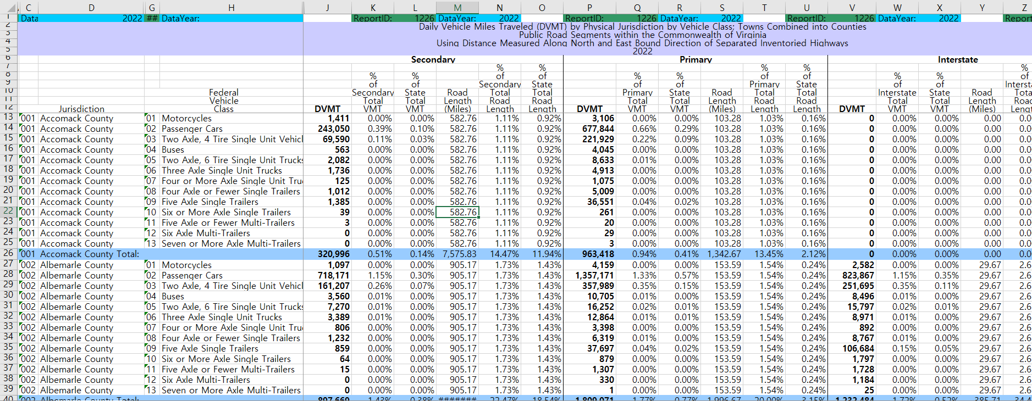

- How the Data Were Processed
  - Mapping. The following tables present the mapping of roadway classifications and federal vehicle classes to the VisionEval model categories. This step ensures that data from the source file (vmtreport_1226) can be accurately integrated into the marea_dvmt_split_by_road_class.csv input. Road types were mapped based on functional class (e.g., Interstate -> Freeway), and vehicle types were grouped according to VisionEval’s Light-Duty Vehicles (Ldv), Heavy Trucks (HvyTrk), and Buses (Bus) categories.
vmtreport_1226 | VisionEval
Interstate | Freeway
Primary | Arterial
Secondary | Other

Federal Vehicle Class |  | VisionEval
01 | Motorcycles | Excluded
02 | Passenger Cars | Ldv
03 | Two Axle, 4 Tire Single Unit Vehicles | Ldv
04 | Buses | Bus
05 | Two Axle, 6 Tire Single Unit Trucks | HvyTrk
06 | Three Axle Single Unit Trucks | HvyTrk
07 | Four or More Axle Single Unit Trucks | HvyTrk
08 | Four Axle or Fewer Single Trailers | HvyTrk
09 | Five Axle Single Trailers | HvyTrk
10 | Six or More Axle Single Trailers | HvyTrk
11 | Five Axle or Fewer Multi-Trailers | HvyTrk
12 | Six Axle Multi-Trailers | HvyTrk
13 | Seven or More Axle Multi-Trailers | HvyTrk

  - VMT Aggregation. To calculate total VMT by jurisdiction, vehicle class, and road category, the SUMIFS function was used in Excel. This function allows for summing values conditionally based on multiple criteria—specifically, County/City, Vehicle Class, and Road Type. (The original dataset was cleaned and reformatted for clarity, and the SUMIFS function was used to perform the aggregation.) 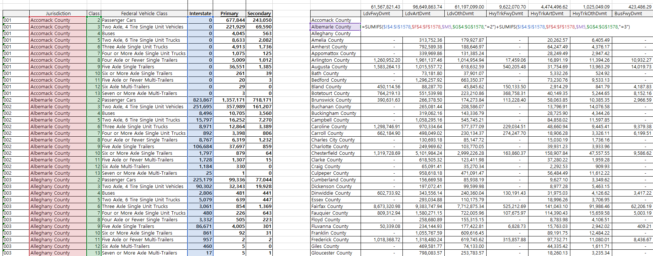
  - Ratio Calculation. Based on the aggregated VMT data calculated in Section 3.2, the proportion of VMT by vehicle class was calculated for each county and city.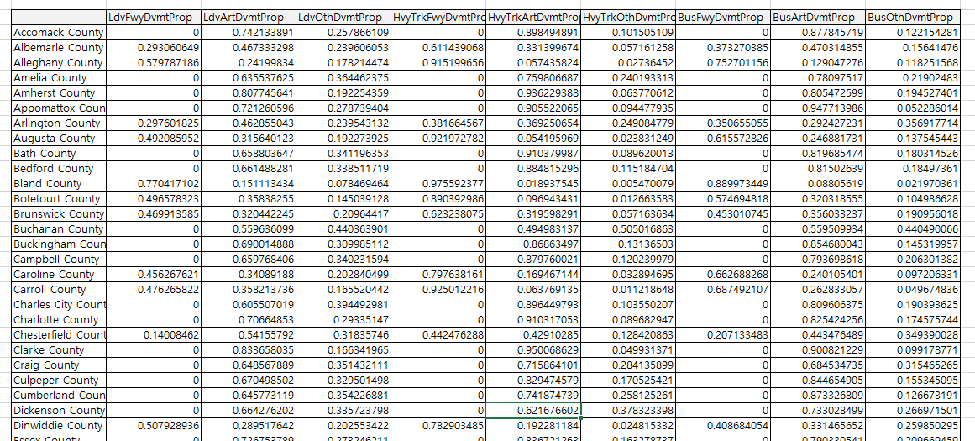
  - Result. Based on the proportions calculated in Section 3.3, the results were entered into a CSV file in the format required by the VisionEval model.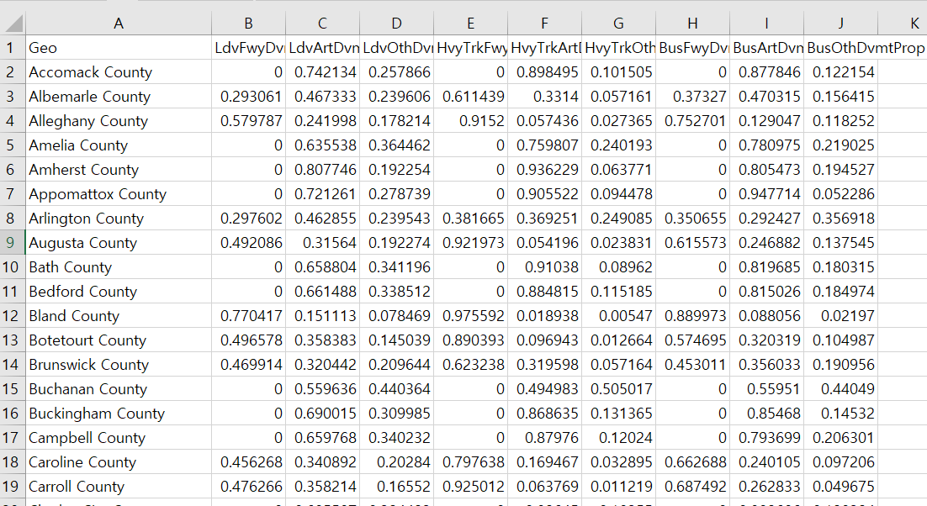

Note: The order of Count/City was revised on July 9, 2025, to align with the Appendix: Geography Standard for consistency with the azone structure.
Note: When saving to CSV, numeric precision is limited to 9 decimal places. As a result, the sum of proportions across vehicle types may not equal exactly 1. Manual recalibration is necessary. (Updated: Sep 15, 2025)
- 2024 Data Projection: The 2024 value was projected by calculating the compound annual growth rate (CAGR) based on three years of historical data (2020–2022).(Updated July 9, 2025)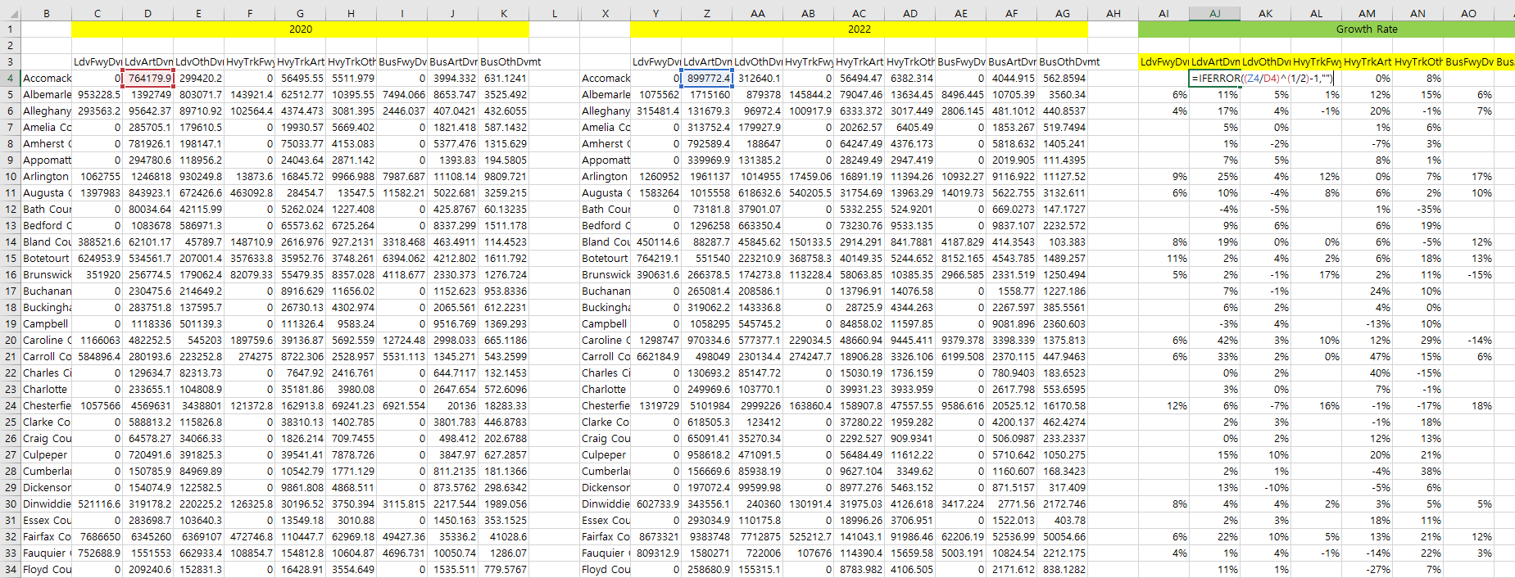
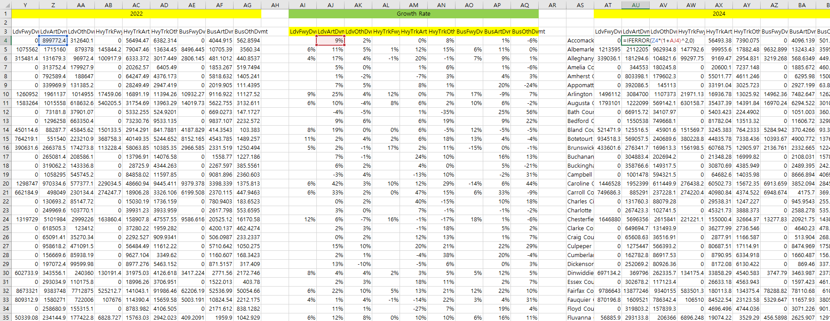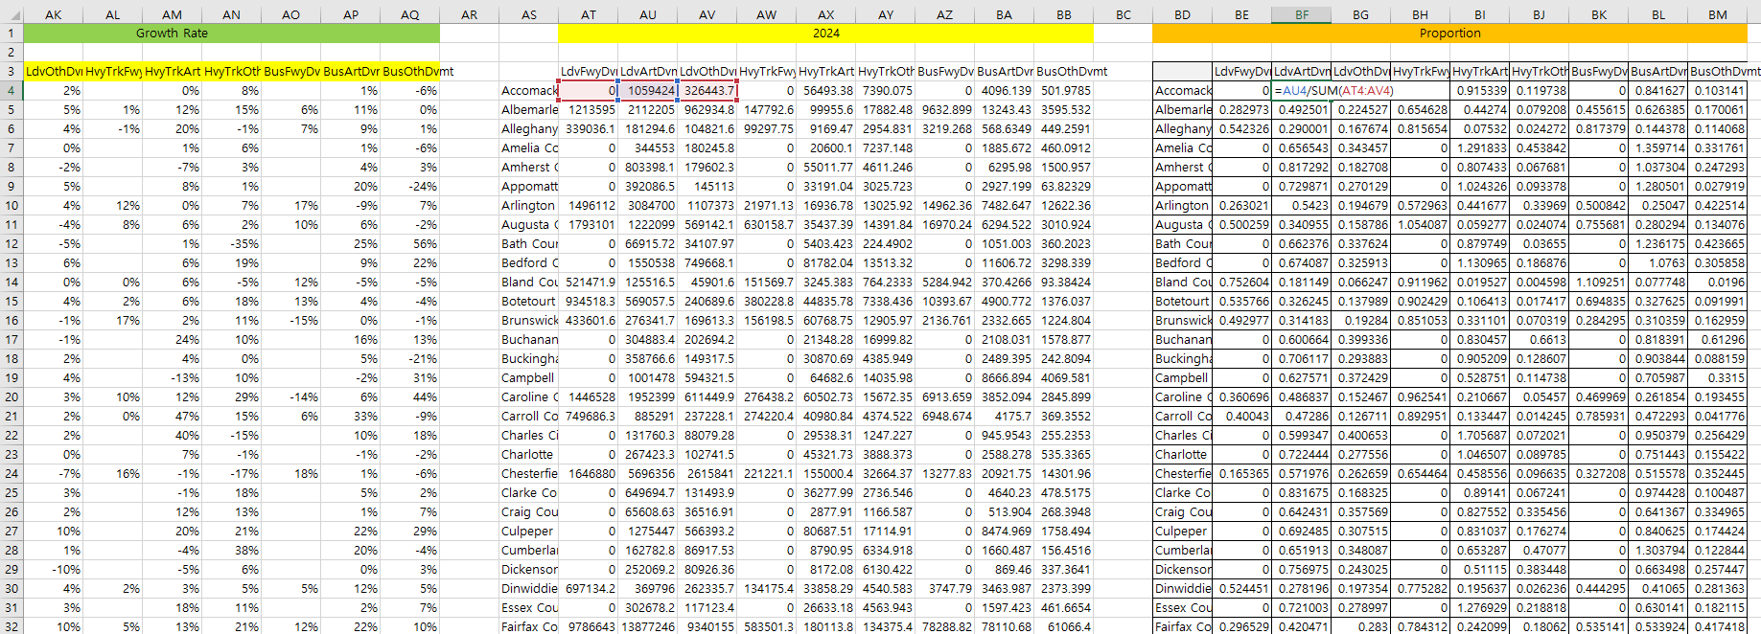
Appendix. Geography Standard
Purpose: To ensure consistency in the geography used for VisionEval inputs, the following standard was established based on the azone geography.
Number | Name | Number | Name | Number | Name
1 | Accomack County | 51 | Goochland County | 101 | Prince William County
2 | Albemarle County | 52 | Grayson County | 102 | Pulaski County
3 | Alexandria City | 53 | Greene County | 103 | Radford City
4 | Alleghany County | 54 | Greensville County | 104 | Rappahannock County
5 | Amelia County | 55 | Halifax County | 105 | Richmond City
6 | Amherst County | 56 | Hampton City | 106 | Richmond County
7 | Appomattox County | 57 | Hanover County | 107 | Roanoke City
8 | Arlington County | 58 | Harrisonburg City | 108 | Roanoke County
9 | Augusta County | 59 | Henrico County | 109 | Rockbridge County
10 | Bath County | 60 | Henry County | 110 | Rockingham County
11 | Bedford County | 61 | Highland County | 111 | Russell County
12 | Bland County | 62 | Hopewell City | 112 | Salem City
13 | Botetourt County | 63 | Isle of Wight County | 113 | Scott County
14 | Bristol City | 64 | James City County | 114 | Shenandoah County
15 | Brunswick County | 65 | King and Queen County | 115 | Smyth County
16 | Buchanan County | 66 | King George County | 116 | Southampton County
17 | Buckingham County | 67 | King William County | 117 | Spotsylvania County
18 | Buena Vista City | 68 | Lancaster County | 118 | Stafford County
19 | Campbell County | 69 | Lee County | 119 | Staunton City
20 | Caroline County | 70 | Lexington City | 120 | Suffolk City
21 | Carroll County | 71 | Loudoun County | 121 | Surry County
22 | Charles City County | 72 | Louisa County | 122 | Sussex County
23 | Charlotte County | 73 | Lunenburg County | 123 | Tazewell County
24 | Charlottesville City | 74 | Lynchburg City | 124 | Virginia Beach City
25 | Chesapeake City | 75 | Madison County | 125 | Warren County
26 | Chesterfield County | 76 | Manassas City | 126 | Washington County
27 | Clarke County | 77 | Manassas Park City | 127 | Waynesboro City
28 | Colonial Heights City | 78 | Martinsville City | 128 | Westmoreland County
29 | Covington City | 79 | Mathews County | 129 | Williamsburg City
30 | Craig County | 80 | Mecklenburg County | 130 | Winchester City
31 | Culpeper County | 81 | Middlesex County | 131 | Wise County
32 | Cumberland County | 82 | Montgomery County | 132 | Wythe County
33 | Danville City | 83 | Nelson County | 133 | York County
34 | Dickenson County | 84 | New Kent County
35 | Dinwiddie County | 85 | Newport News City
36 | Emporia City | 86 | Norfolk City
37 | Essex County | 87 | Northampton County
38 | Fairfax City | 88 | Northumberland County
39 | Fairfax County | 89 | Norton City
40 | Falls Church City | 90 | Nottoway County
41 | Fauquier County | 91 | Orange County
42 | Floyd County | 92 | Page County
43 | Fluvanna County | 93 | Patrick County
44 | Franklin City | 94 | Petersburg City
45 | Franklin County | 95 | Pittsylvania County
46 | Frederick County | 96 | Poquoson City
47 | Fredericksburg City | 97 | Portsmouth City
48 | Galax City | 98 | Powhatan County
49 | Giles County | 99 | Prince Edward County
50 | Gloucester County | 100 | Prince George County

